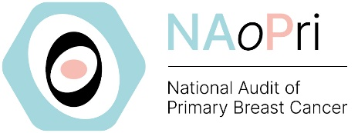 |  | Patient and Public Involvement (PPI) Forum Member Expression of Interest Form
The National Audit of Primary Breast Cancer (NAoPri) PPI Forum is a consultative and advisory group for the Audit. It consists of up to 15 members who have been diagnosed with primary breast cancer, or are a friend, family member, or carer to a person with primary breast cancer. Its purpose is to help ensure the voice of patients is reflected in the direction and delivery of the NAoPri.
If you have read the advert and think you would like to be involved in the NAoPri PPI Forum,  please complete this form and return it to us via  e-mail to breastcanceraudits@rcseng.ac.uk |  |  |  | The details shared in this form will be used to help ensure the NAoPri PPI Forum embraces the wide spectrum of patients affected by primary breast cancer within England and Wales.
Personal Details
Full Name: |  |  | Age:
Gender: |  |  | Postcode:
Ethnicity: |  |  | E-mail address:
Please tell us more about your primary breast cancer experiences
Please highlight/mark the box which best describes you:
☐ Current patient with primary breast cancer
☐ Previous patient with primary breast cancer (please provide the year you were diagnosed __________)
☐ Friend, family member, or carer to someone with primary breast cancer
☐ Other (please describe) ____________________________________________________________________

Please briefly summarise your experiences of primary breast cancer and treatments (personal, or as a friend, family member, or carer). Please include details about the type (including ER/HER2 status) and stage of breast cancer if you feel comfortable sharing. It is also helpful for us if you can include the dates of any treatments you received.

Why would you like to be involved in the NAoPri PPI Forum?

Would you be comfortable to Chair the NAoPri PPI Forum if you were nominated? ☐ Yes ☐ No
Please confirm that we have your permission to hold and use the information provided on this form for the purposes of this audit:
☐ I consent to you retaining my information for the purposes of the work of the NAoPri.
☐ I consent to you contacting me with information pertaining to the NAoPri via e-mail.
The details shared in this form will be retained for the length of the audit, handled in accordance with the GDPR and will not be used for any other purpose without consent.
Please send your completed form or any questions to: breastcanceraudits@rcseng.ac.uk

