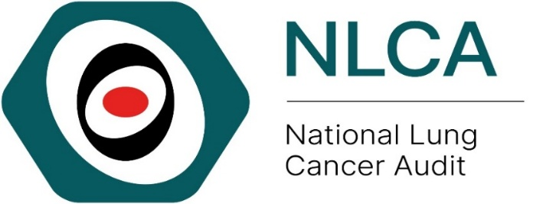

Local Action Plan for Improving Access to LCNS Care: National Lung Cancer Audit Quality Improvement Initiative
The provider should complete the following details to allow for ease of review
Audit title & aim: | Improving Access to LCNS Care: National Lung Cancer Audit Quality Improvement Initiative  To increase the proportion of patients with lung cancer receiving care from a Lung Cancer Nurse Specialist (LCNS)  To improve the data completeness of LCNS data in the Cancer Outcomes and Services Data set (COSD)
NHS organisation:

Audit lead:

Action plan lead:

When making your action plan, make sure to keep the objectives SMART – Specific, Measurable, Assignable, Realistic, Time-related
This quality improvement template is designed to be used in conjunction with the NLCA provider level results on our interactive data dashboard and quality improvement resources presented on our website.

Key 1 (for the action status)
- Awaiting plan of action
- Action in progress
- Action fully implemented
- No plan to action recommendation (state reason)
- Other (provide information)
Key 2 (for the action priority)
High: requires urgent attention (local audit)
Medium: requires prompt action (consider local audit)
Low: requires no immediate action (or local audit)

 |  |  | Action activities
No. | Recommendation | Action required? | Responsible individual(s) | Agreed deadline | Status (Key 1) | Priority (Key 2)
1 | Improve LCNS provision | Suggested actions:  - Review trust-level performance on LCNS access using NLCA dashboard.  - Identify barriers to ensuring every patient is seen by an LCNS.  - Explore options to expand coverage across all clinical settings.
2 | Enhance data completeness | Suggested actions:  - Ensure all LCNS staff are trained in COSD completion and coding categories (Y1, Y3, Y4).  - Nominate a lead nurse to validate LCNS data monthly.
3 | Review staffing and workload | Suggested actions:  - Assess LCNS: patient ratio and compare with NOLCP recommendation (≤1:40).  - Consider developing a business case to increase LCNS capacity if needed.
4 | Understand patient experience | Suggested actions:  - Undertake local patient feedback or survey to identify gaps in LCNS support.  - Use findings to inform service improvement priorities.
5 |  | Suggested actions:

Please contact the NLCA team nlca@rcseng.ac.uk if you have any questions related to your results, data collection or service improvement. We also welcome on feedback on the audit, report or quality improvement resources.

References
- NLCA State of the Nation Reports and Interactive Data Dashboards National Lung Cancer Audit (NLCA) - National Cancer Audit Collaborating Centre
- NICE Guidelines Lung Cancer - Lung cancer: diagnosis and management (2019) NICE guideline [NG122] Treatment | Lung cancer: diagnosis and management | Guidance | NICE
- NHS England. National Optimal Lung Cancer Pathway (NOLCP) https://rmpartners.nhs.uk/wp-content/uploads/2024/09/national-optimal-lung-cancer-pathway_v4_01jan2024.pdf
- NHS Wales. National Optimal Lung Cancer Pathway (NOLCP) NHS Wales. National optimal pathway for lung cancer: 2nd Edition (2022)
- Lung Cancer Nursing UK Home | Lung Cancer Nursing UK

