Understanding the Systemic Anti-Cancer Therapy (SACT) Dataflow

The Systemic Anti-Cancer Therapy (SACT) dataset is submitted by each provider through the English National Cancer Online Registration Environment (ENCORE)application programming interface (API) web portal, which is also used for other datasets such as the radiotherapy dataset (RTDS) and cancer outcomes registration dataset (COSD)¹. This platform allows providers to track upload progress and ensures that files conform to National Disease Registration Service (NDRS) specifications. Submissions must be formatted as CSV files following NDRS guidance². NDRS monitor monthly uploads, identify providers with consistently lower-than-expected activity, and work with these trusts to investigate the cause of reduced submissions¹. This data flow is illustrated in the diagram below:

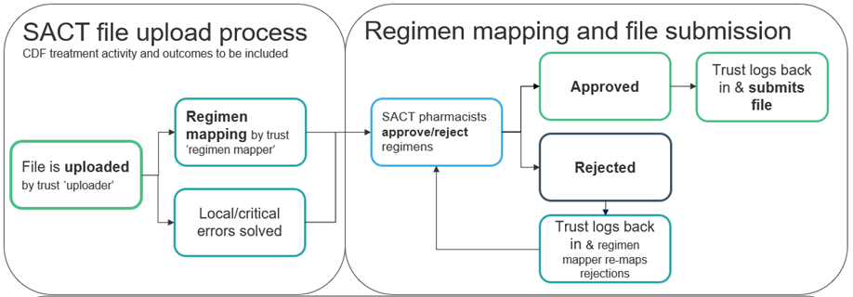
Figure 1. An adapted ‘overview of the monthly SACT data collection schedule, including routine SACT submissions’¹

Regimen Mapping and Data-Upload Process
Once trusts upload their data, each file undergoes a regimen-mapping process within the portal.

🔑 Key steps include:
- Mapping new regimens:
  - When a regimen has not previously been recorded, local hospital pharmacists collaborate with one of the four national pharmacists to agree the correct classification.
  - If required, national pharmacists advise whether a new regimen code should be created.
  - National pharmacists (who advise on regimen allocation but are not employed by NDRS) communicate their decisions back to providers by leaving comments directly in the portal.

- Reviewing upload errors:
  - Trusts can view issues by selecting the “Batch Report” option within the actions tab.
  - Errors are displayed with accompanying severity levels to guide local follow-up.

- Cycle and timeliness:
  - According to NDRS, the mapping and review cycle occurs monthly and is resolved within the same month.
  - This makes it unlikely that regimen mapping is responsible for missing or delayed SACT submissions.
  - Newly adopted regimens introduced through recent Cancer Drugs Fund approvals or emerging trial evidence therefore would not be expected to explain persistently low submission levels.

Provider-Level Roles and Local Workflow
Regimen mapping at trust level also involves a designated regimen mapper, typically a local pharmacist, who responds to queries or requests from national pharmacists for additional detail.

Three key provider-level roles are understood to underpin smooth SACT submission:
- Trust SACT uploader
- Cancer manager
- Lead pharmacist

However, the configuration of these roles varies considerably across organisations:
- In some trusts, each role is clearly defined and delivered by separate individuals.
- In others, responsibilities may be shared or consolidated.
  - For example, in resource-limited settings, a pharmacist may undertake both regimen mapping and data-upload duties.
  - Alternatively, a cancer manager may oversee both coordination and data-quality functions.

Please see Box 1 below, which describes this process from the perspective of a local provider.

Box 1. Perspective from a local provider

Data Manager
From the perspective of a data manager, SACT extraction typically begins with pulling data from electronic patient record (EPR) systems into a spreadsheet formatted according to NDRS requirements. This trust used EPIC and a list of other EPR systems being used by NHS Trusts can be found here. Automated columns within the template highlight missing data for review and include a mortality flag for patients who died within 30 days of treatment, enabling validation of treatment receipt. This extraction and checking process usually takes between half a day and a full working day. Providers switching between or integrating multiple IT systems may face added complexity; for example, one peripheral site previously using MOSAIQ for SACT encountered issues due to differing system configurations and transitioned to EPIC for SACT alone. One of the possible issues was a potential misclassification of oral SACT as “TTO” which meant it was being dispensed on their local system instead of EPIC, thus not registering the SACT regime prescribed on EPIC where data is currently extracted from.

Pharmacist
From the pharmacist’s perspective, the regimen-mapping step involves logging into the API portal to address flagged items. On average, around 20 files per month require review. While most single-agent regimens take approximately 30 seconds to map while combination therapies, such as platinum-based treatments require more time. When entirely new regimens are encountered, pharmacists submit a query to NDRS requesting national mapping. Once approved, the new regimen appears in the portal and can then be applied automatically to all relevant patients.
Compliance metrics and submission status, for SACT and other datasets, are available through the CancerStats2 platform, which provides monthly updates from NDRS. All trusts therefore use the same national systems for data submission (the API portal) and for reviewing data outputs (CancerStats2). To keep up to date with latest news from the NDRS SACT data team, subscribe here to their quarterly SACT data newsletter.

References
- https://digital.nhs.uk/ndrs/data/data-sets/sact/sact-escalation-process
- https://digital.nhs.uk/ndrs/data/data-sets/sact/sact-data-set-technical-guidance#validation

NDRS Regional Data Liaison Team

Your local Data Improvement Lead at NDRS will be able to help you find out information about your SACT submissions.

Please see below the list of regional contacts.

National
Karen Graham
karen.graham36@nhs.net

East Midlands
Simon Cairnes
simon.cairnes@nhs.net

Eastern
Marianne Mollett
marianne.mollett@nhs.net

London
Katrina Sung
katrina.sung@nhs.net

North West
Paul Stacey
p.stacey@nhs.net

Northern and Yorkshire
Rachel Mann
rachaelmann@nhs.net

Oxford
Gemma Feeney
gemma.feeney@nhs.net
South West
James Withers
james.withers@nhs.net

West Midlands
Gemma Feeney
gemma.feeney@nhs.net

