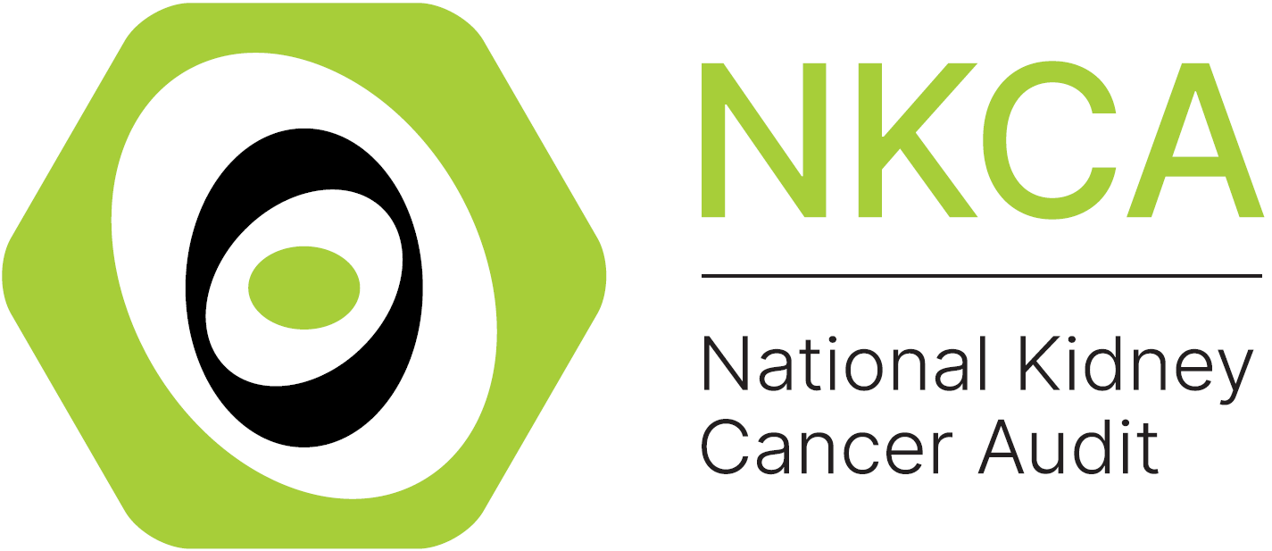

Local Action Plan for Improving Access to CNS Care: National Kidney Cancer Audit Quality Improvement Intervention
The provider should complete the following details to allow for ease of review
Audit title & aim: | National Kidney Cancer Audit (NKCA)  To increase the proportion of patients with kidney cancer receiving care from a Cancer Nurse Specialist (CNS)  To improve the data completeness of CNS data in the Cancer Outcomes and Services Data set (COSD)
NHS organisation:
Audit lead:
Action plan lead:
When making your action plan, make sure to keep the objectives SMART – Specific, Measurable, Assignable, Realistic, Time-related

Key 1 (for the action status)
- Awaiting plan of action
- Action in progress
- Action fully implemented
- No plan to action recommendation (state reason)
- Other (provide information)
Key 2 (for the action priority)
High: requires urgent attention (local audit)
Medium: requires prompt action (consider local audit)
Low: requires no immediate action (or local audit)

 |  |  | Action activities
No. | Recommendation | Suggested Actions | Responsible individual(s) | Agreed deadline | Status (Key 1) | Priority (Key 2)
1 | Improve CNS provision | - Review trust-level performance on CNS access using NKCA dashboard.  - Identify structural and process barriers preventing patients from having CNS contact at diagnosis.  - Explore options to expand coverage across all clinical settings (emergency and inpatient).
2 | Enhance data completeness | - Ensure all CNS staff are trained in COSD completion and coding categories (Y1, Y3, Y4, Y5).  - Nominate a lead nurse to validate CNS data monthly.
3 | Review staffing and workload | - Audit current CNS caseload and assess whether existing capacity meets patient need.  - Developing a business case to increase CNS capacity where capacity gaps are identified.
4 | Ensure CNS checklist completion | - Implement routine use of the NKCA CNS checklist at diagnosis to ensure standardised assessment of patient needs.
5 | Understand patient experience | - Undertake local patient feedback or survey to identify gaps in CNS support.  - Use findings to inform service improvement priorities.
Please contact the NKCA team Kidneycanceraudit@rcseng.ac.uk if you have any questions related to your results, data collection or service improvement.

